Hormones Name:_________________
Using Chapter 7.2 Pearson Science 9
The hormonal system is called the _______________ system. Hormones are ___________________ which act as ________________ in the body. Organs that produce hormones are called ________________ ______________. There are many endocrine glands and together they form the ________________ system. These glands are called endocrine glands because they release their hormones directly into the _______________ not to the outside of the body as a salivary gland or sweat gland does. Endo means inside.
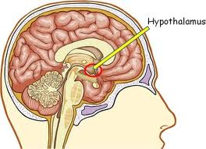
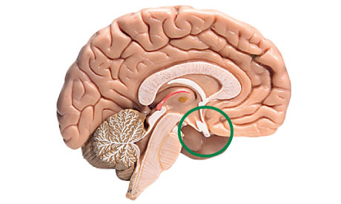
The________________ gland coordinates the endocrine system. The pituitary gland follows instructions from the _________________.
The hypothalamus is very important because it links the _____________ and ________________ systems.
Target Cells
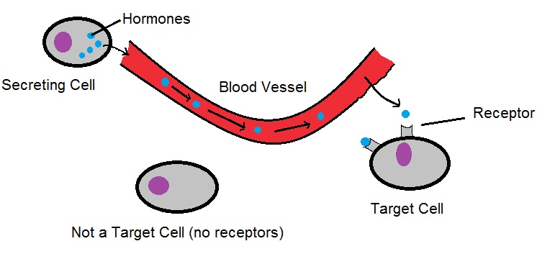
Hormones are ___________, this means they only affect particular cells. They cells they affect are called ___________ ________.
Each hormone has a different chemical structure which means it is a different shape. Target cells have specially shaped __________ on them. The hormone fits into its own target cells receptor like a jigsaw puzzle piece, no other hormones will fit.

Homeostasis
Homeostasis is the process of _______________________________________ ________________________________________________________________
Homeostasis requires receptors that __________________________________ and effectors that _________________________________________________.

How hormones help maintain Homeostasis:
Use the following words (you may use them more than once): endocrine, less, receptors, hypothalamus, hormone, hormones, homeostasis, pituitary gland, blood stream, target cells
Hormones from the pituitary gland travel around the body in the ______ _______ to other ________________ glands
____________ receives message from the hypothalamus and responds by releasing more or __________ of particular _____________ into the body.
____________ monitors the body’s internal environment via ___________. If changes are required it sends __________ to the __________ gland.

The target cells respond and the internal environment of the body is changed in an attempt to maintain ___________.

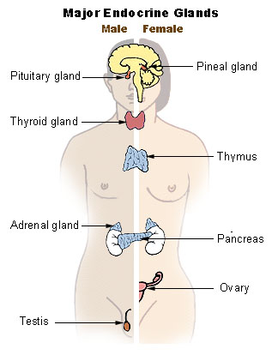

Only the target gland is affected by each particular hormone. The amount of ___________ it receives tells the endocrine gland to release more or less of its own hormones

Hormones from the endocrine glands only affect particular cells in the body called ___________ __________

